**Sales Store Prediction**

**Wireframe**

**Document Version - 1.0**

**Last Revision date - 30/01/2023**

**Written By – Arpit Kumar Maurya**

**Contents**

1 Abstract ------------------------------------------------ 3

2 Web Interface ---------------------------------------- 3

3 User Input --------------------------------------------- 4

4 Result Page ------------------------------------------ 5

1. **Abstract**

Nowadays, shopping malls and Big Marts keep track of individual item sales data in order to forecast future client demand and adjust inventory management. In a data warehouse, these data stores hold a significant amount of consumer information and particular item details. By mining the data store from the data warehouse, more anomalies and common patterns can be discovered.

1. **Web Interface**

Our web page is one single interface where both input from the user and the prediction is displayed.

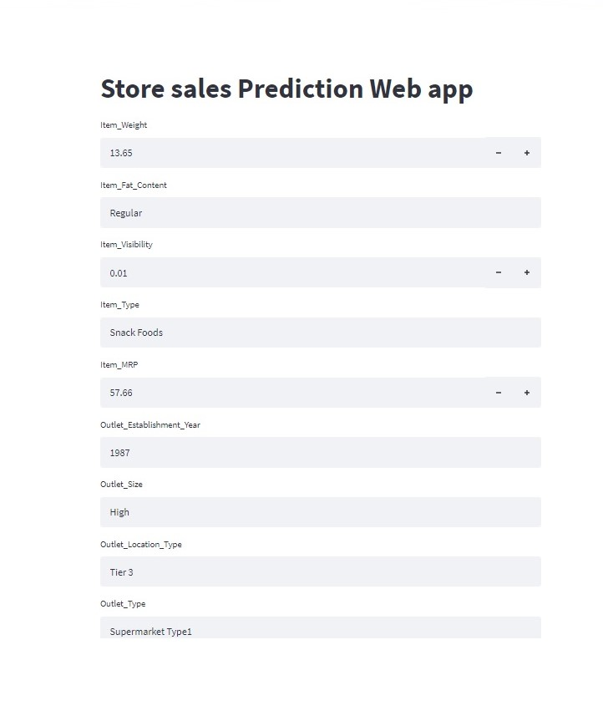

1. **User Input**

Whenever the user hits our url, they first see the user input page here they have to provide the information like:

• Every user input has its own dropdown where the user can select their input.

• After providing the required input and pressing the submit button, the page refreshes and displays the output

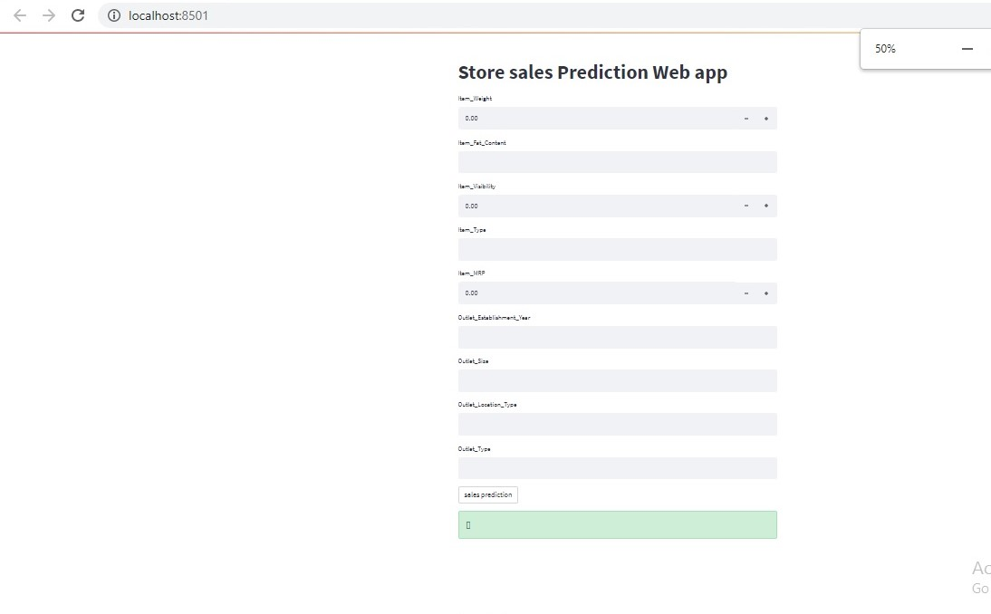

1. **Result Page**

After the user hits the submit button the page gets refreshed and the results are being displayed in the highlighted area in the above frame.

The user can refill all the inputs in same page and get the results in the same way.

